1. Create a script named “myscript” in current directory to do the following.

a) create a dir named “subd1” in current directory

command: mkdir subd1

create vi myscript.sh

b) create a file named “dircontent” with contents of the current directory

command: $ touch dircontent

c) display the contents of the file “dircontent”

command: $ cat dircontent

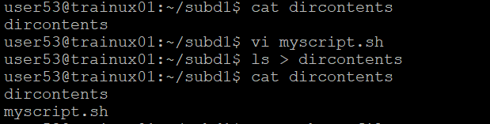

d) display the contents of a non existing file named “unknownfile”

command : $ cat unknownfile



2. Run the script and validate the output in following cases

a) Redirect only the stdout to an o/p file named stdout.txt

command: $ ./myscript.sh > stdout.txt

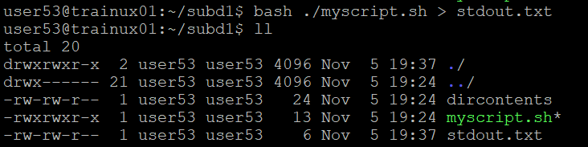

b) Redirect only the stderr to an o/p file named stderr.txt

command: $ ./myscript.sh 2> stderr.txt



c) Redirect both stdout and stderr to an o/p file named stdall.txt

command: $ ./myscript.sh &> stdall.txt

d) Display all o/p and error and also redirect both stdout and stderr to an o/p file named stdall.txt

command: $ ./myscript.sh |& tee stdall.txt



3. Redirect the output of command below using pipe (|) to wc and get the output .

ls –

command: $ ls -1 | wc

